**Lab report #8**

**Sadovskaya Veronika**

**Task 1 - CREATE Schema of simple Data Warehouse Architecture**

|  |  |  |  |
| --- | --- | --- | --- |
| Level Type | Object Name | Tablespace | Description |
| Storage Level  SA_* | SA_CLIENTS | ts_sa_clients_data_01 | Loading from structured files (exp. XML*). Contains information about client. |
| SA_ORDERS | ts_sa_orders_data_01 | Loading from float files. Contains information about order. |
| SA_EMPLOYEES | ts_sa_employees_data_01 | Loading from structured files (exp. XML*). Contains information about employee. |
| DW – Cleansing level | DW_CL | ts_dw_cl | Loading from stage level system. Contains all information prepare it for further usage (cleaning it). |
| DW – Level | DW_DATA | ts_dw_data_01 | LOADING data from cleansing system. Contains clean information tending to the 3rd normal form ready for preparing star schema. |
| DW – Prepare Star Cleansing Level | SAL_DW_CL | ts_dw_str_cls | LOADING data from DW system. Contains views merging objects from DW level. |
| STAR - Cleansing | SAL_CL | ts_sal_cl | LOADING data from DW_CL system. Contains views from previous level but clean any redundancy. |
| STAR - Level | DM_CLIENT | ts_sa_dim_client_01 | Store information about dim client. |
| DM_ORDER | ts_sa_fct_order_01 | Store information about fact order. |
| DM_EMPLOYEE | ts_sa_dim_employee_01 | Store information about dim employee. |
| DM_RESTAURANT | ts_sa_dim_restaurant_01 | Store information about dim restaurant. |
| DM_DISH | ts_sa_dim_dish_01 | Store information about dim dish. |
| DM_PAYMENT_METHOD | ts_sa_dim_payment_method_01 | Store information about dim payment method. |

**Task 2 – CREATE Storage Level**

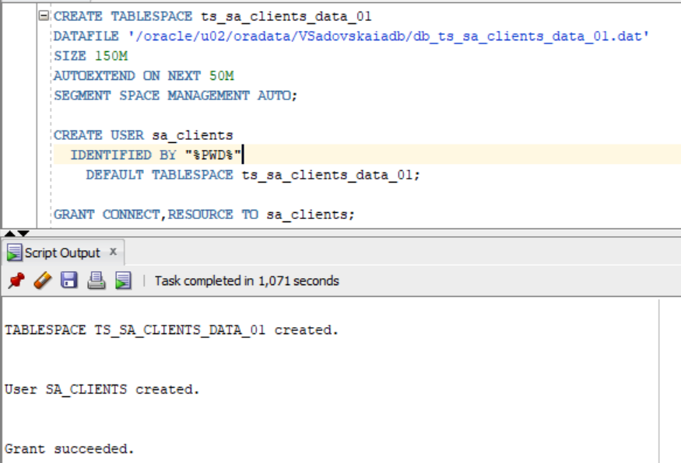

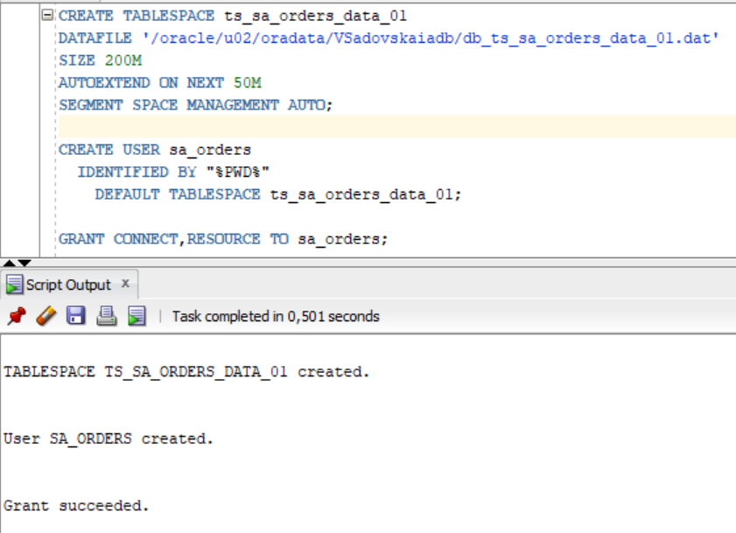

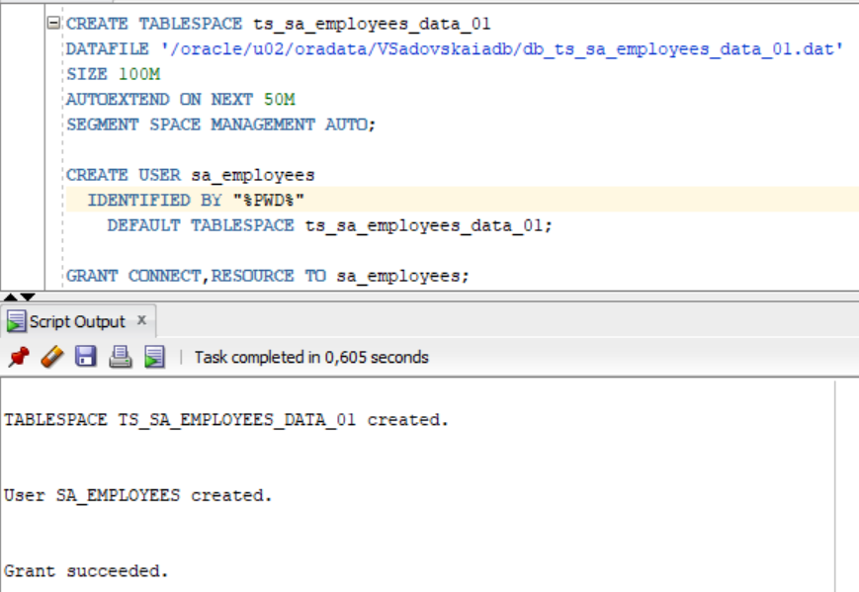

**Task 3 – CREATE Data warehouse Cleansing Level**

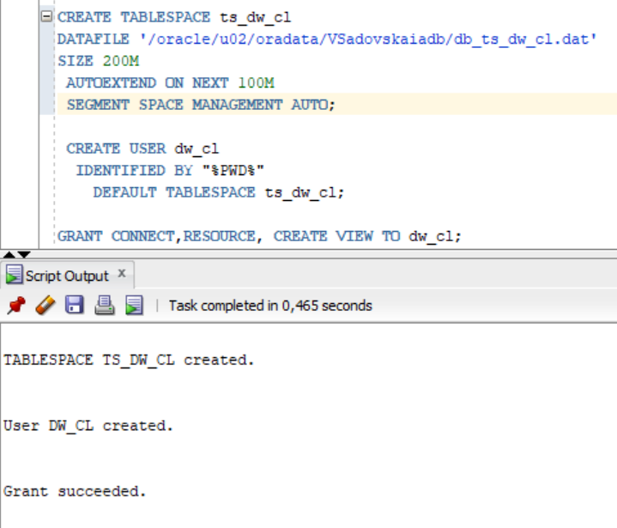

**Task 4 – CREATE Data warehouse Start Cleansing Level**

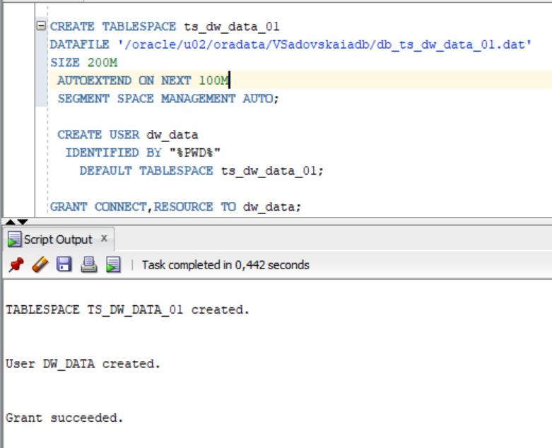

**Task 5 – CREATE Start Cleansing Level**

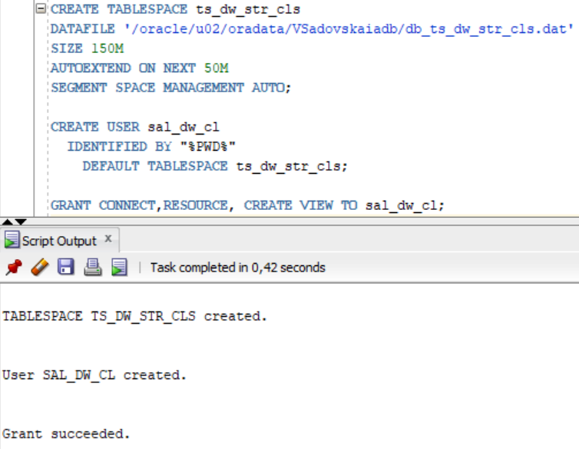

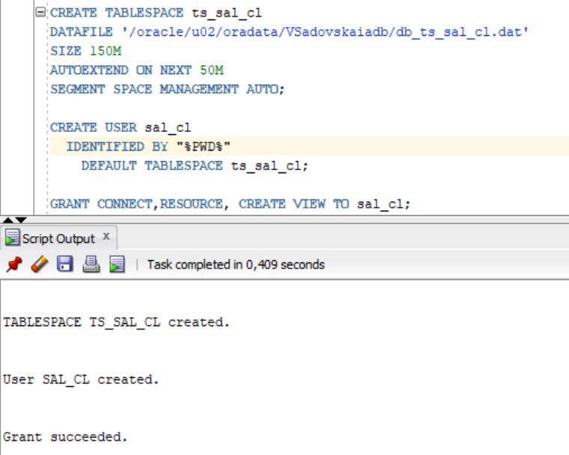

**Task 6 – CREATE Data warehouse Start Level and Data Marts**

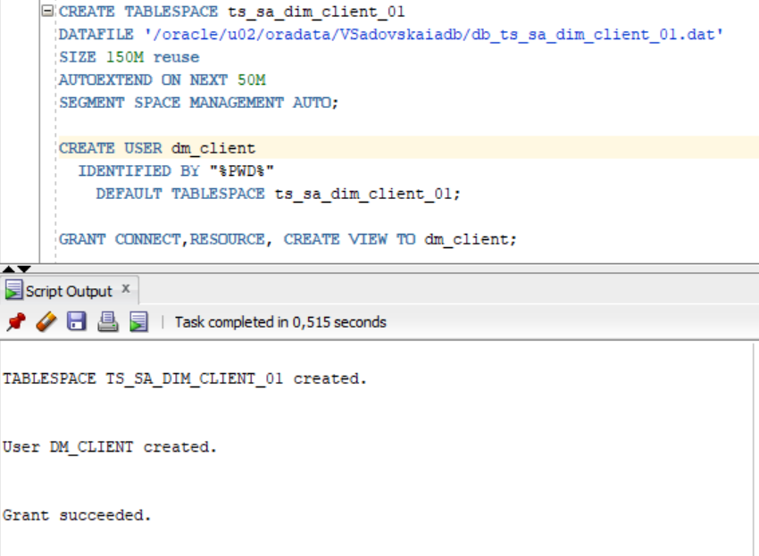

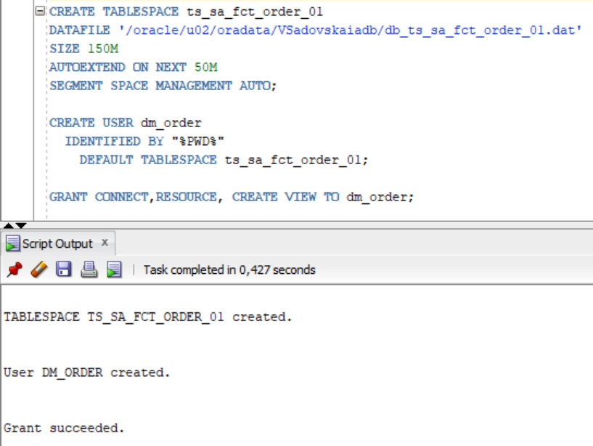

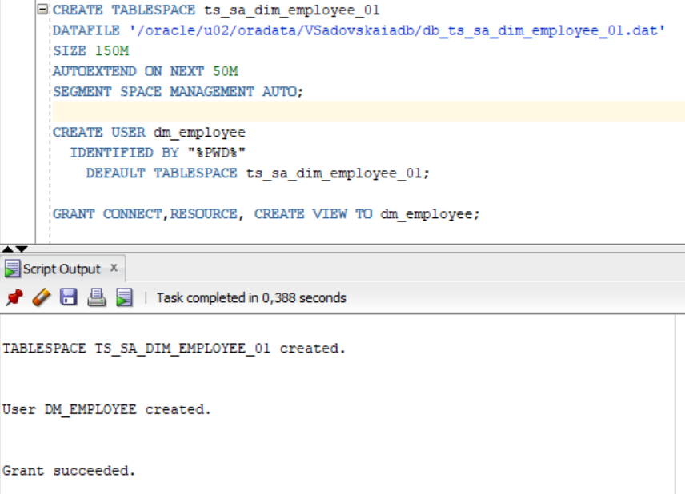

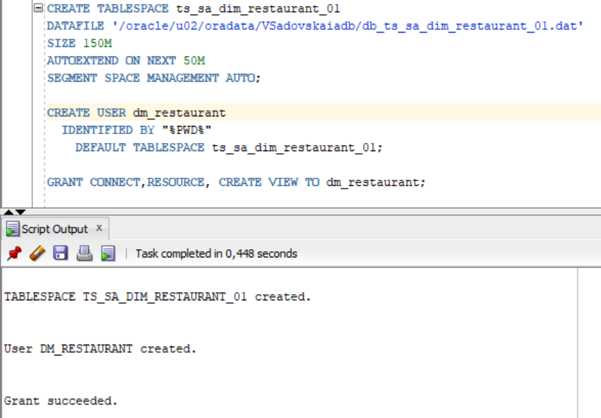

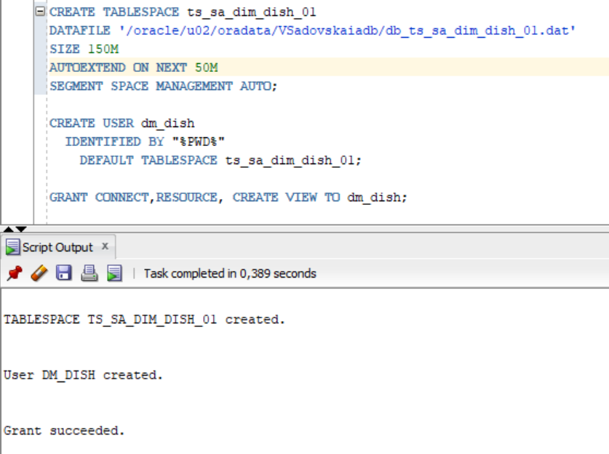

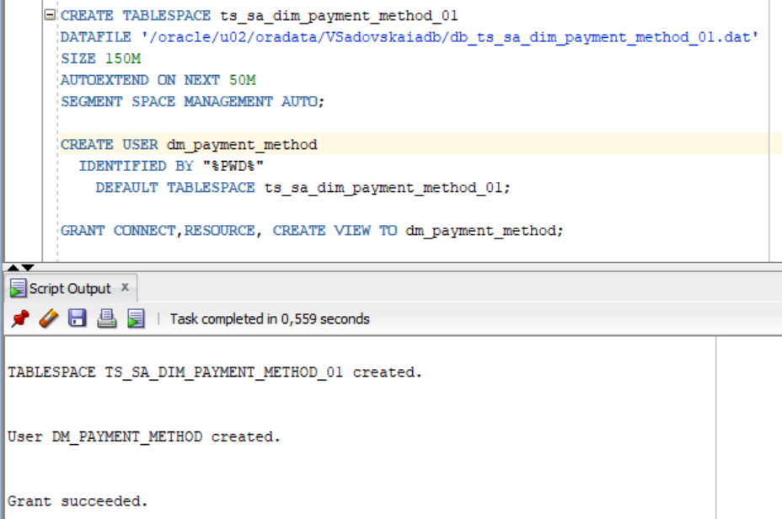

**Task 7 – CREATE Prepared Star Objects**

Git: <https://github.com/sdveronika/DataMola22>

**Task 8 - DataFlow Diagram**

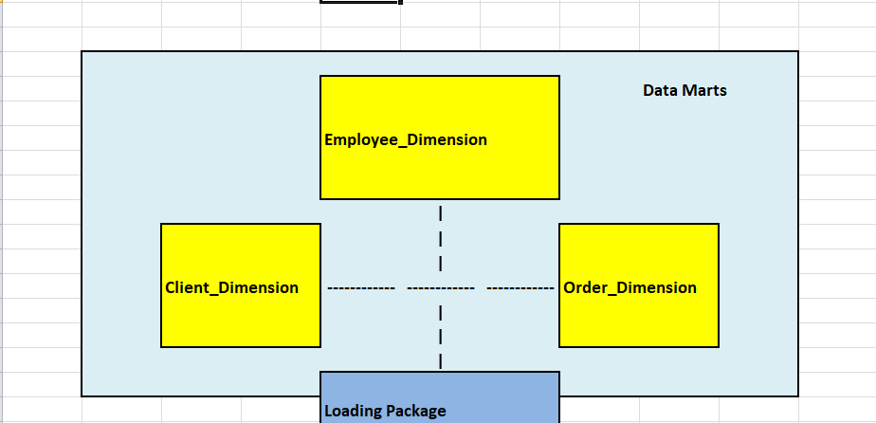

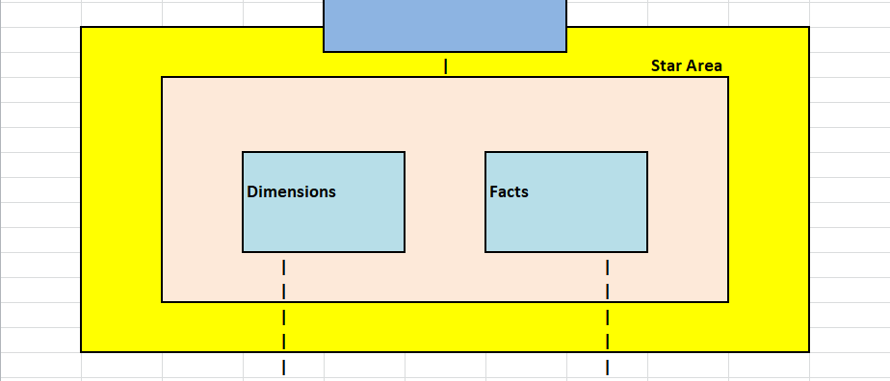

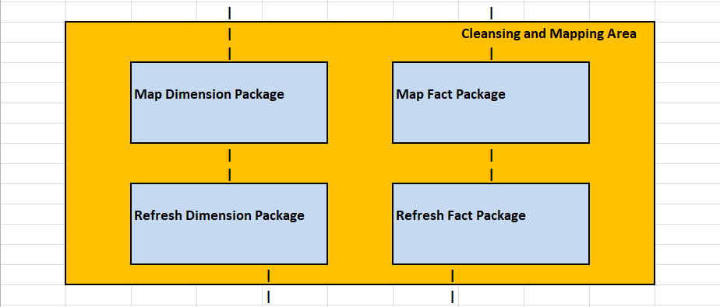

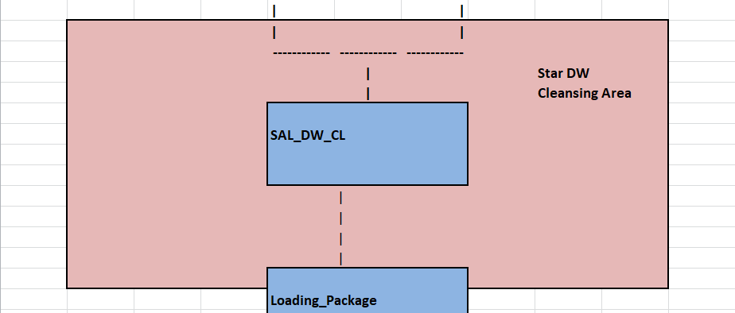

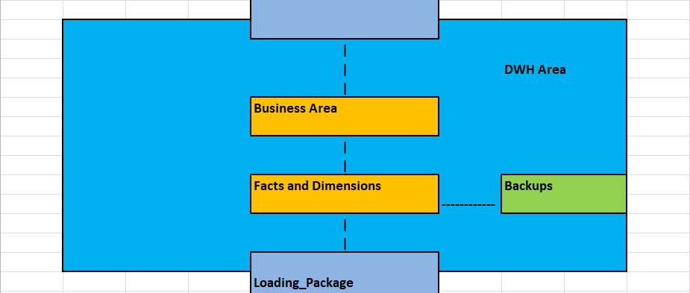

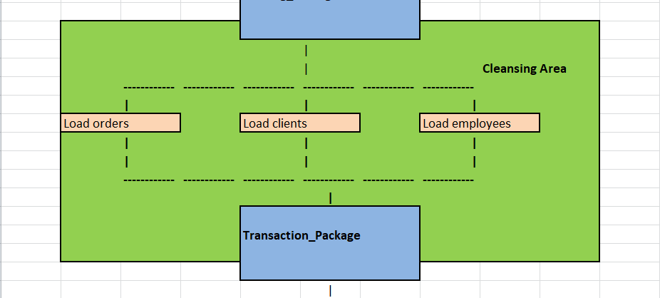

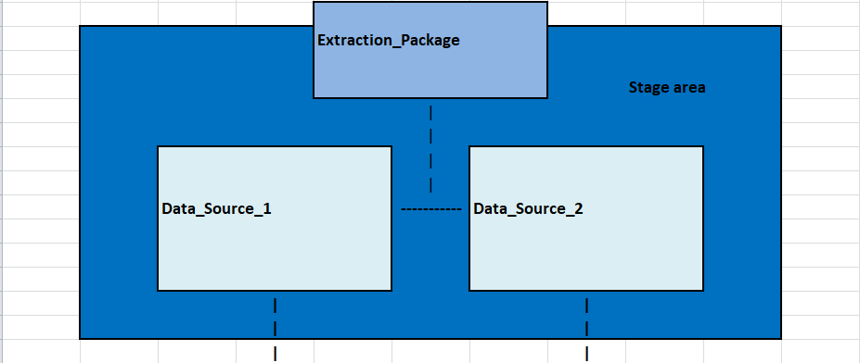

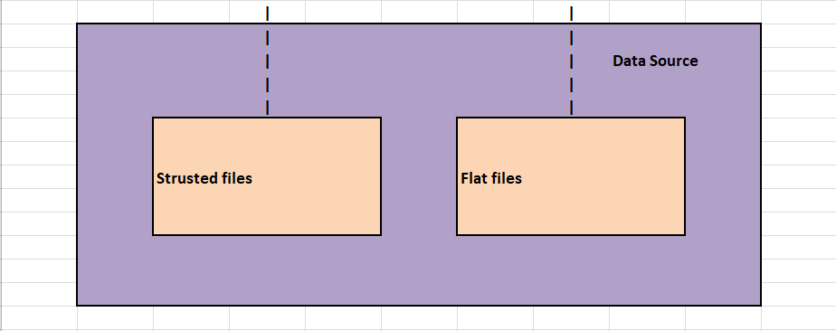

**Task 9 - Grants Object Privileges**

All privileges are on the screenshots in tasks 1-6.